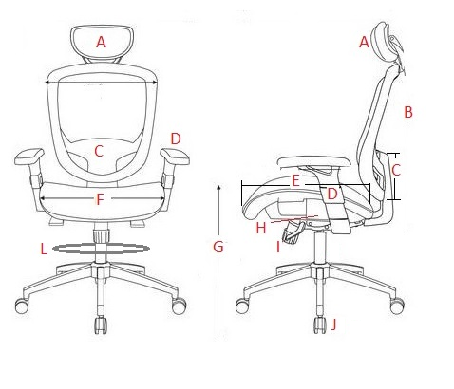
QTY: ______
☐ Rotary Chair
☐ Rotary Chair large occupant
☐ Rotary Stool

Link to annex A technical spec from the furniture website

 | Criteria | Requirement Choices
A | Headrest | ☐ No ☐ Yes ☐ No preference
B | Backrest Height | ☐ Standard = height between 450mm (17.7 in.) to 660 mm (25.9 in.)  ☐ High = height greater than 660mm (26 in.)  ☐ No preference
B | Backrest Style Preference(s) | 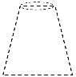  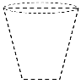  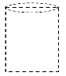  Note: style represents overall shape, but the design may vary.  ☐ No preference ☐ ☐ ☐ ☐
C | Lumbar Support | ☐ Adjustable = min. 50mm (2 in.) adjustment between 150mm (5.9 in.) to 250mm (9.8 in.) for height |  |  |  | ☐ Up/down  ☐ In/out  ☐ In/out & up/down
 |  | ☐ Fixed = between 150 mm (5.9 in.) to 250 mm (9.8 in.)
 |  | ☐ No preference
D | Armrests | ☐ Adjustable |  | ☐ height = HEIGHT: min. 63mm (2.5 in.) adjustment between 176mm (6.9 in.) to 289mm (11.4 in.)  ☐ height & width = WIDTH: min.75mm (3 in.) between 443mm (17 in.) to 493mm (19.4 in.)  ☐ height, width & pivot = PIVOT: min. 20 degrees inward and min. 10 degrees outward  ☐ pivot
 |  | ☐ Fixed = height range between 200 mm (7.9 in.) to 250 mm (9.8 in.)
 |  | ☐ None (no Armrests)
E | Seat Depth | ☐ Adjustable = min. 50mm (2 in.) adjustment within the range 420mm (16.5 in.) to 460mm (18.1 in.)
 |  | ☐ Fixed |  | ☐ Shallow = 380mm (15 in.) to 420mm (16.5 in.)  ☐ Medium = greater than 420mm (16.5 in.) to 460mm (18.1 in.)  ☐ Deep = greater than 460mm (18.1 in.)
 |  | ☐ No preference
F | Seat Width | Standard rotary chairs and stools have a minimum width of 450mm (17.7in.)  Large Occupant models have a minimum width of 560mm (22 in.)
G | Seat Height | Rotary Chair |  | ☐ Adjustable | ☐ Standard = includes 417mm (16.4 in.) or less to 512mm (20.2in.) or more  ☐ Low = includes 376mm (14.8 in.) to 439mm (17.3 in.)
 |  |  |  | ☐ Fixed = between 417mm (16.4 in.) to 512mm (20.2 in.)
 |  | Rotary Stool |  | ☐ Fixed = must be equal or greater than 670 mm (27.5 in).  ☐ Adjustable = must include range from 580mm (23 in.) to 840 mm (33 in.).
H | Tilt Mechanism | ☐ Synchro tilt = seat and backrest tilt at the same time in a simultaneous movement, with the seat in a ratio greater than 1:1  ☐ Unison tilt = Seat and backrest (including knee) tilt in unison, a ratio of 1:1  ☐ Back tilt = Seat angle and back angle adjustment to be adjustable independently of each other  ☐ No preference
I | Seat and Backrest Locks | ☐ Setup Position = seat is in the most horizontal position and the backrest in the most vertical position  ☐ Multiple Positions = includes the setup position and additional angles of seat and backrest  ☐ No preference
J | Casters | ☐ carpet = for carpeted/ soft floors ☐ hard surface = for hard surfaced floors
L | Foot Ring | Standard with stool models only
 | Upholstery | Backrest | ☐ Upholstery ☐ Mesh ☐ Other ____________
 |  | Seat | ☐ Upholstery ☐ Mesh ☐ Other ____________
 |  | ☐ No preference
 | Additional Criteria | Add any additional criteria in this section that is not brand specific like additional padding, frame finish, removable armrests, etc.

Side Chair | QTY: ______
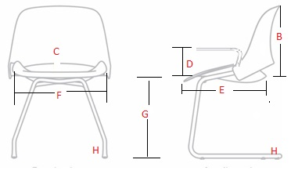

Link to Annex A technical specifications

 | Criteria | Requirement Choices
B | Backrest Height | standard with minimum height of 354 mm (13.9 in)
 | Backrest Style Preference(s) | 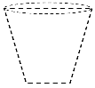  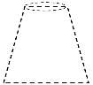  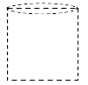  Note: style represents overall shape, but the design may vary.  No preference ☐ ☐ ☐ ☐
C | Lumbar Support | ☐ No  ☐ Yes = between 150 mm (5.9 in.) to 250 mm (9.8 in.)
D | Armrests | ☐ Fixed = height range between 200 mm (7.9 in.) to 250 mm (9.8 in.)
 |  | ☐ Adjustable |  | ☐ Height only = HEIGHT: min. 63mm (2.5 in.) adjustment between 176mm (6.9 in.) to 289mm (11.4 in.)  ☐ Height & width only = WIDTH: min.75mm (3 in.) between 443mm (17 in.) to 493mm (19.4 in.)
 |  | ☐ No Armrest
E | Seat Depth | ☐ Fixed |  | ☐ Shallow = 380mm (15 in.) to 420mm (16.5 in.)  ☐ Medium = greater than 420mm (16.5 in.) to 460mm (18.1 in.)  ☐ Deep = greater than 460mm (18.1 in.)  ☐ No preference
F | Seat Width | standard with minimum width of 400mm (15.7in.)
G | Seat Height | Fixed = between 417mm (16.4 in.) to 512mm (20.2 in.)
H | Stacking: | ☐ nesting (horizontal stacking) ☐ (vertical stacking) ☐ No preference
 | Base Style | ☐ Legs (4 post) |  | ☐ Casters ☐ Glides ☐ Other:
☐ Sled
☐ Cantilever
☐ Other ___________
☐ No preference
 | Upholstery | Backrest | ☐ Upholstery ☐ Mesh ☐ Other ____________
 |  | Seat | ☐ Upholstery ☐ Mesh ☐ Other ____________
 |  | ☐ No preference
 | Additional Criteria | Add any additional criteria in this section that is not brand specific like additional padding, frame finish, removable armrests , etc.

